Microservices with Spring Boot 3 and Spring Cloud

## **Microservices with API gateway**

**1)CREATING MICROSERVICES FOR ACCOUNT AND LOAN**

**Account.java**

package com.cognizant.account;

public class Account {

private String number;

private String type;

private double balance;

public Account(String number, String type, double balance) {

this.number = number;

this.type = type;

this.balance = balance;

}

public String getNumber() { return number; }

public void setNumber(String number) { this.number = number; }

public String getType() { return type; }

public void setType(String type) { this.type = type; }

public double getBalance() { return balance; }

public void setBalance(double balance) { this.balance = balance; }

}

**AccountController.java**

package com.cognizant.account;

import org.springframework.web.bind.annotation.*;

@RestController

public class AccountController {

@GetMapping("/accounts/{number}")

public Account getAccount(@PathVariable String number) {

return new Account(number, "savings", 234343);

}

}

**OUTPUT:**

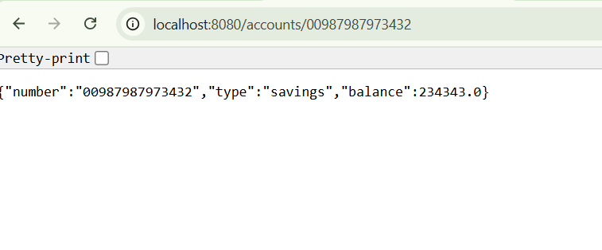

**2)CREATE LOAD MICROSERVICE:**

**LoanController.java**

package com.cognizant.loan;

import org.springframework.web.bind.annotation.*;

@RestController

public class LoanController {

@GetMapping("/loans/{number}")

public Loan getLoan(@PathVariable String number) {

return new Loan(number, "car", 400000, 3258, 18);

}

}

**Loan.java**

package com.cognizant.loan;

public class Loan {

private String number;

private String type;

private double loan;

private double emi;

private int tenure;

public Loan(String number, String type, double loan, double emi, int tenure) {

this.number = number;

this.type = type;

this.loan = loan;

this.emi = emi;

this.tenure = tenure;

}

public String getNumber() { return number; }

public void setNumber(String number) { this.number = number; }

public String getType() { return type; }

public void setType(String type) { this.type = type; }

public double getLoan() { return loan; }

public void setLoan(double loan) { this.loan = loan; }

public double getEmi() { return emi; }

public void setEmi(double emi) { this.emi = emi; }

public int getTenure() { return tenure; }

public void setTenure(int tenure) { this.tenure = tenure; }

}

**OUTPUT:**

